Effective Unit Testing for Contact, Task & Appointment Management

Michael Crevier

Southern New Hampshire University

CS 320: Software Test Automation & QA

**Professor** Jeff Philips

April 20, 2024

In today's fast-paced software development landscape, ensuring application reliability and efficiency is more critical than ever. This paper dives into the unit testing strategies employed for three crucial components within a software application: contact management, task management, and appointment management. Each component underwent rigorous testing using JUnit, a popular framework in the Java world. This testing strategy went beyond verifying basic functionalities; it carefully examined edge cases and robust error handling, aiming to build a secure and dependable software foundation. The following sections will explore the testing methodologies applied, analyze their alignment with software requirements, and evaluate the overall effectiveness and efficiency of the implemented tests.

My comprehensive unit testing strategy played a crucial role in guaranteeing the application's ability to flawlessly manage a contact's entire lifecycle. These tests meticulously validated each data field against established criteria, ensuring consistent data integrity. For example, they verified unique and correctly formatted contact IDs, appropriate character limits for names, valid 10-digit phone numbers, and concise addresses. Notably, these tests went beyond basic functionality by examining edge cases, such as attempts to update or delete non-existent contacts. This robust approach not only ensured a seamless user experience but also minimized the risk of unexpected behavior down the line.

Following a similar approach, unit tests for tasks focused on the unique characteristics of their lifecycle. They verified the generation of unique and properly formatted task IDs, ensured adherence to the defined name length limit (up to 20 characters), and validated that descriptions remained within the specified 50-character constraint. The core functionalities of adding, updating, and deleting tasks were rigorously tested to guarantee reliable task tracking and a seamless user experience.

Unit testing for appointment management prioritized robust date validation, ensuring the system only allowed scheduling for future appointments. This focus on data integrity complemented thorough testing of standard CRUD (Create, Read, Update, Delete) operations. Additionally, tests verified the uniqueness of appointment IDs and the system's ability to handle description fields appropriately, including enforcing the defined character limit. This comprehensive testing strategy aimed to guarantee not only accurate appointment scheduling but also a reliable user experience.

The unit testing strategy demonstrated a close alignment with the software's established requirements. This tight integration was evident in the structured validation checks incorporated within the tests. For instance, a group of contact management tests directly assessed the system's adherence to the respective character limits for contact IDs, contact first name and contact last name by attempting to create a contact with invalid lengths at these parameters and verifying that it throws an *IllegalArgumentException* for each:  
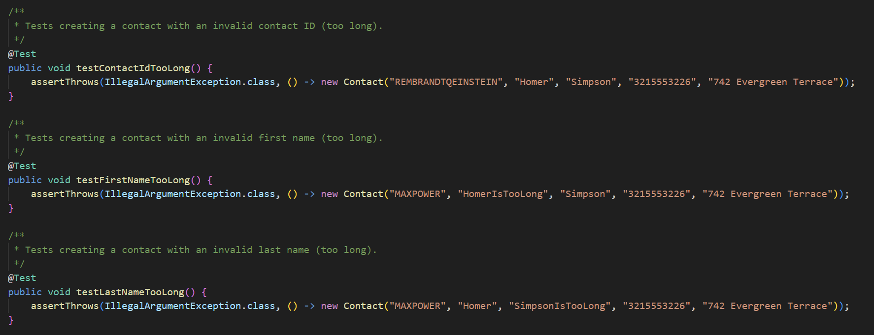

This approach of directly mapping requirements to tests was consistently applied across all features, guaranteeing comprehensive coverage of all defined functionalities. This comprehensive testing strategy not only ensured the system functioned as intended but also minimized the risk of future discrepancies between requirements and actual behavior.

The high JUnit test coverage metric of above 85% serves as a strong indicator of the test suite's effectiveness. This exceptional coverage percentage signifies a broad and inclusive evaluation of the codebase, encompassing a wide spectrum of scenarios. The tests thoroughly examined typical user interactions, explored boundary conditions (edge cases), and verified the system's ability to handle errors gracefully. This commitment to testing both expected and unexpected situations underscores the effectiveness of the test suite in ensuring the application's reliability and stability. By systematically covering both normal and exceptional paths, the tests provide a solid foundation for guaranteeing consistent and dependable application behavior under a variety of conditions.

Writing JUnit tests demanded a methodical approach, where a thorough understanding of the application's requirements and potential usage scenarios was essential. It was a process that presented both challenges and rewards. Crafting tests that closely mimicked real-world usage was demanding, but ultimately enhanced my grasp of the application's functionality and potential edge cases. This deep dive into the application's behavior proved invaluable. Technical soundness was ensured by writing comprehensive test cases that not only verified functionality but also documented the expected behavior for each requirement. For example, a contact service test demonstrates this approach:

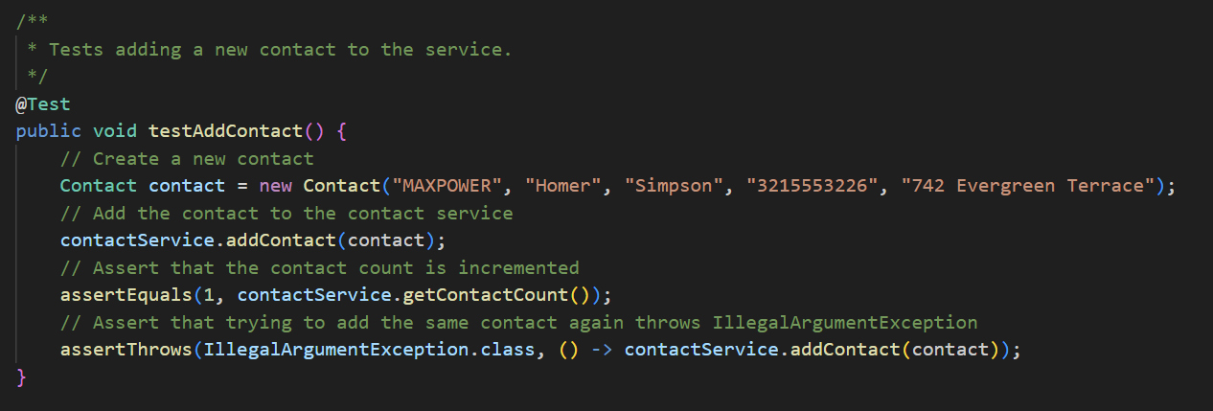

This test verifies that the *contactService* correctly updates the contact count after adding a new contact, while also verifies that each unique contact can only be added once. Similar tests were written for all functionalities, ensuring robust validation. Efficiency in the codebase was achieved by utilizing data structures and algorithms optimized for performance. Storing contacts and tasks in a HashMap offered constant-time complexity for retrieval and update operations:  
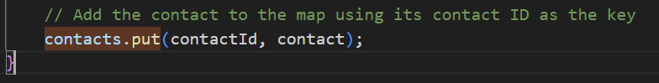

This is crucial for maintaining performance as the amount of data grows. By leveraging efficient data structures, the application ensures quick access to information, even with a large number of contacts or tasks.

This project heavily relied on unit testing, a technique that isolates individual program components and verifies their functionality independently. It involves writing tests for each non-trivial function or method, ensuring they behave as expected under various conditions. JUnit is a popular framework used for unit testing, often incorporating mock objects to simulate complex dependencies. While integration testing and system testing weren't employed here, it's important to understand their roles. Integration testing combines logically grouped units to verify their interactions and interface compatibility. System testing, on the other hand, assesses the entire integrated software product against its defined requirements. The choice of testing method depends on project characteristics. Unit testing shines in early issue detection, making it ideal for agile methodologies with rapid development cycles. Integration testing becomes vital for projects with multiple interacting subsystems, especially in complex enterprise environments. Finally, system testing is critical for consumer-facing applications where a software failure can have significant consequences and ensures the entire product meets all requirements before release.

Throughout the project, I adopted a cautious and systematic approach, keenly aware of the software's complexities and interdependencies. Understanding these interactions, like how tasks might link to contacts or appointments, was essential for crafting effective tests. To mitigate bias and ensure comprehensive coverage, I implemented a diverse range of test scenarios and implemented code review results as provided by comments from the milestone feedback. This feedback acted as a proxy for peer code reviews, which are used to gain a fresh prospective and avoid the problems of overlooking edge cases or subtle bugs which could cause significant issues later in the coding lifecycle. Maintaining high code quality is paramount for future reliability, maintainability, and scalability. Taking shortcuts can create a scenario where seemingly small issues accumulate, leading to costly fixes later. To prevent this, I would plan to employ strategies like regular refactoring, adherence to coding standards, thorough documentation, and continuous testing. An example is using continuous integration tools that automatically run tests with every code commit, helping catch issues early and preventing a backlog of unaddressed bugs.

The project's commitment to rigorous testing delivered two key benefits: meeting initial requirements and establishing a strong foundation for future growth. The high test coverage metric signifies a comprehensive testing strategy that effectively identifies potential issues before deployment. More importantly, this experience underscores the value of a disciplined testing approach. By prioritizing quality, thoroughness, and proactive error detection, we minimized the future burden caused by needing to go back and change code later. As software systems inevitably grow in complexity, the principles and practices outlined here will serve as a valuable roadmap for maintaining software reliability and performance. This focus on quality testing ultimately contributes to the successful delivery of robust software solutions in any development scenario.